Help Change your Community
U.S. State & Local Government
POLS 3310
Fall 2026
Mon/Wed 8 – 9:15 a.m.  BINAB 2.212  Instructor: Dr. Ragland |  |  | 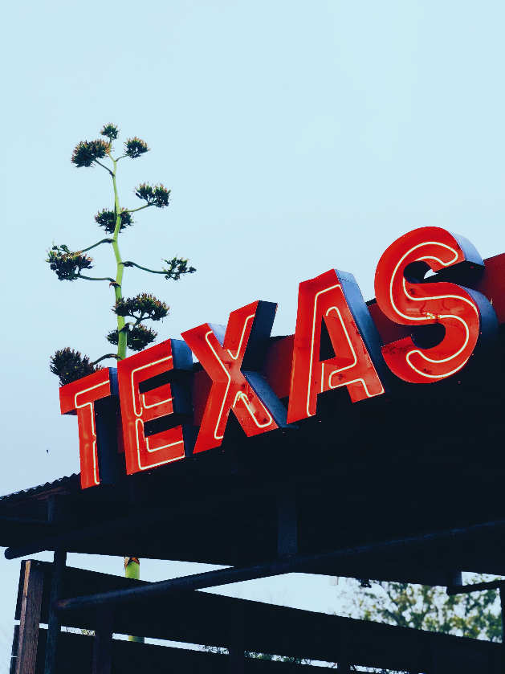

State and Local Power
Elections * Local Boards * Your Vote!

